The FA Charter Standard
YORK FUTSAL CLUB RULES

1. NAME
York Futsal shall be called (the “Club”).

2. OBJECTS
The objects of the Club shall be to provide facilities, promote the game of Association Football (FUTSAL), to arrange matches and social activities for its members, and community participation in the same.

3. STATUS OF RULES
These Rules (the “Club Rules”) form a binding agreement between each member of the Club.

4. RULES AND REGULATIONS
(a) The members of the Club shall so exercise their rights, powers and duties and shall, where appropriate, use their best endeavours to ensure that others conduct themselves so that the business and affairs of the Club are carried out in accordance with the Rules and Regulation of The Football Association Limited (“The FA”), County Football Association to which the Club is affiliated (“Parent County Association”) and Competitions in which the Club participates, for the time being in force.
(b) No alteration to the Club Rules shall be effective without written approval by the Parent County Association. The FA and the Parent County Association reserve the right to approve any proposed changes to the Club Rules.
(c) The Club will also abide by The FA’s Safeguarding Children Policies and Procedures, Codes of Conduct and the Equal Opportunities and Anti-Discrimination Policy as shall be in place from time to time.

5. CLUB MEMBERSHIP
(a) The members of the Club from time to time shall be those persons listed in the register of members (the “Membership Register”) which shall be maintained by the Club Secretary.
(b) Any person who wishes to be a member must apply on the Membership Application Form and deliver it to the Club. Election to membership shall be at the discretion of the Club Committee and granted in accordance with the anti-discrimination and equality policies which are in place from time to time. An appeal against refusal may be made to the Club Committee in accordance with the Complaints Procedure in place from time to time. Membership shall become effective upon an applicant’s name being entered in the Membership Register.
(c) In the event of a member’s resignation or expulsion, his or her name shall be removed from the Membership Register.
(d) The FA and Parent County Association shall be given access to the Membership Register on demand.
1
2
6. ANNUAL MEMBERSHIP FEE
(a) An annual fee payable by each member shall be determined from time to time by the Club Committee and set at a level that will not pose a significant obstacle to community participation. Any fee shall be payable on a successful application for membership and annually by each member. Fees shall not be repayable.
(b) The Club Committee shall have the authority to levy further subscriptions from the members as are reasonably necessary to fulfil the objects of the Club.

7. RESIGNATION AND EXPULSION
(a) A member shall cease to be a member of the Club if, and from the date on which, he/she gives notice to the Club Committee of his / her resignation. A member whose annual membership fee or further subscription is more than two (2) months in arrears shall be deemed to have resigned.
(b) The Club Committee shall have the power to expel a member when, in its opinion, it would not be in the interests of the club for them to remain a member. An appeal against such a decision may be made to the Club Committee in accordance with the Complaints Procedure in force from time to time.
(c) A member who resigns or is expelled shall not be entitled to claim any, or any share of, any, of the income and assets of the Club (the “Club Property”).

8. CLUB COMMITTEE
(a) The Club Committee shall consist of the following Club Officers: Chairperson, Vice Chairperson, Treasurer, Secretary, Minutes Secretary and up to five (5) other members, all elected at an Annual General Meeting (“AGM”).
(b) Each Club Officer and Club Committee Member shall hold office from the date of appointment until the next AGM unless otherwise resolved at an Extraordinary General Meeting (“EGM”). One person may hold no more than two (2) positions of Club Officer at any time. The Club Committee shall be responsible for the management of all the affairs of the Club. Decisions of the Club Committee shall be made by a simple majority of those attending the Club Committee meeting. The Chairperson of the Club Committee meeting
shall have a casting vote in the event of a tie. Meetings of the Club Committee shall be chaired by the or in their absence the The quorum for the transaction of the business of the Club Committee shall be three (3).
(c) Decisions of the Club Committee shall be entered into the Minute Book of the Club to be maintained by the Club Secretary.
(d) Any member of the Club Committee may call a meeting of the Club Committee by giving not less than seven days’ notice to all members of the Club Committee. The Club Committee shall hold not less than four (4) meetings per year.
(e) An outgoing member of the Club Committee may be re-elected. Any vacancy on the Club Committee which arises between AGMs shall be filled by a member proposed by one (1) and seconded by another one (1) of the remaining Club Committee members and approved by simple majority of the remaining Club Committee members.
(f) Save as provided for in the Rules and Regulations of The FA, the Parent County Association and any applicable Competition, the Club Committee shall have the power to decide all questions and disputes arising in respect of any issue concerning the Club Rules.
(g) The position of a Club Officer shall be vacated if such a person is subject to a decision of The FA that such person be suspended from holding office or from taking part in any football (Futsal) activity relating to the administration or management of a football (Futsal) club.
THE FA CHARTER STANDARD CLUB RULES
THE FA CHARTER STANDARD CLUB RULES
9. ANNUAL AND EXTRAORDINARY GENERAL MEETINGS
(a) An AGM shall be held in each year to:
(i) receive a report of the activities of the Club over the previous year;
(ii) receive a report of the Club’s finances over the previous year;
(iii) elect members of the Club Committee; and
(iv) consider any other business.
(b) Nominations for election of members as Club Officers or as members of the Club Committee shall be made in writing by the proposer and seconder, both of whom must be existing members of the Club, to the Club Secretary not less than 21 days before the AGM. Notice of any resolution to be proposed at the AGM shall be given in writing to the Club Secretary not less than 21 days before the Meeting.

(c) An EGM may be called at any time by the Club Committee and shall be called within 21 days of the receipt by the Club Secretary of a requisition in writing, signed by not less than five members, stating the purposes for which the Meeting is required and the resolutions proposed. Business at an EGM may be any business that may be transacted at an AGM.
(d) The Secretary shall send to each member at their last known address written notice of the date of a General Meeting (whether an AGM or an EGM) together with the resolutions to be proposed at least 14 days before the meeting.
(e) The quorum for a General Meeting shall be
(f) The Chairperson, or in their absence a member selected by the Club Committee, shall take the chair. Each member present shall have one vote and resolutions shall be passed by a simple majority. In the event of an equality of votes, the Chairperson of the Meeting shall have a casting vote.
(g) The Club Secretary, or in their absence a member of the Club Committee, shall enter the Minutes of General Meetings into the Minute Book of the Club.

10. CLUB TEAMS
At its first meeting following each AGM , the Club Committee shall appoint a Club member to be responsible for each of the Club’s futsal teams. The appointed members shall be responsible for managing the affairs of the team. The appointed members shall present to the Club Committee at its last meeting prior to an AGM a written report of the activities of the team.

11. CLUB FINANCES
(a) A bank account shall be opened and maintained in the name of the Club (the “Club Account”). Designated account signatories shall be the Club Chairperson, the Club Secretary and the Club Treasurer. No sum shall be drawn from the Club Account except by cheque signed by two of the three designated signatories. All monies payable to the Club shall be received by the Treasurer and deposited in the Club Account.
(b) The Club Property shall be applied only in furtherance of the objects of the Club. The distribution of profits or proceedings arising from the sale of Club Property to members is prohibited.
(c) The Club Committee shall have the power to authorise the payment of remuneration and expenses to any member of the Club (although a Club shall not remunerate a member for playing) and to any other person or persons for services rendered to the Club.
(d) The Club may provide sporting and related social facilities, sporting equipment, coaching, courses, insurance cover, medical treatment, away match expenses, post-match refreshments and other ordinary benefits of Community Amateur Sports Clubs as provided for in the Finance Act 2002.E FA CHARTER STANDARD CLUB RULES
(e) The Club may also in connection with the sports purposes of the Club:
(i) sell and supply food, drink and related sports clothing and equipment;
(ii) employ members (although not for playing) and remunerate them for providing goods and services,
on fair terms set by the Club Committee without the person concerned being present;
(iii) pay for reasonable hospitality for visiting teams and guests; and(iv) indemnify the Club Committee and members acting properly in the course of the running of the Club against any liability incurred in the proper running of the Club (but only to the extent of its assets).
(f) The Club shall keep accounting records for recording the fact and nature of all payments and receipts so as to disclose, with reasonable accuracy, at any time, the financial position,
including the assets and liabilities of the Club. The Club must retain its accounting records for a minimum of six (6) years.
(g) The Club shall prepare an annual “Financial Statement” in such format as shall be available from The FA from time to time. The Financial Statement shall be verified by an independent, appropriately qualified accountant and shall be approved by members at a General Meeting. A copy of any Financial Statement shall, on demand, be forwarded to The FA.
(h) The Club Property, other than the Club Account, shall be vested in not less than two (2) and not more than four (4) custodians, one of whom shall be the Treasurer (the “Custodians”), who shall deal with the Club Property as directed by decisions of the Club Committee, and entry in the Minute Book shall be conclusive evidence of such a decision.
(i) The Custodians shall be appointed by the Club in a General Meeting and shall hold office until death or resignation unless removed by a resolution passed at a General Meeting.
(j) On their removal or resignation, a Custodian shall execute a Conveyance in such form as is published by The FA from time to time to a newly elected Custodian or the existing Custodians as directed by the Club Committee. The Club shall, on request, make a copy of any Conveyance available to The FA. On the death of a Custodian, any Club Property vested in them shall vest automatically in the surviving Custodians. If there is only one surviving Custodian, an EGM shall be convened as soon as possible to appoint another
Custodian.
(k) The Custodians shall be entitled to an indemnity out of the Club Property for all expenses and other liabilities reasonably incurred by them in carrying out their duties.

12. DISSOLUTION
(a) A resolution to dissolve the Club shall only be proposed at a General Meeting and shall be carried by the majority of at least three-quarters of the members present.
(b) The dissolution shall take effect from the date of the resolution and the members of the Club Committee shall be responsible for the winding up of the assets and liabilities of the Club.
(c) Any surplus assets remaining after the discharge of the debts and liabilities of the Club shall be transferred to another Club, a Competition, the Parent County Association or The FA for use by them related to community sports.

The FA Charter Standard
YORK FUTSAL DISCIPLINARY POLICY & GUIDLINES
[In conjunction with Club Constitution Document]
[RESPECT Code of Conduct – Players, Parents/Carers and Managers /Coaches]
[Team Managers Responsibilities Document]
  - DISCIPLINARY PROCESS
Stages to consider:
Stage 1 – A one to one meeting with person concerned. In the case of a player either the CWO or a parent/guardian to be present. Confirm with email follow-up. Confirm that the situation will be monitored.
Stage 2 – If the issue is repeated or continues then the Disciplinary Committee will issue a written warning as to future conduct via email or letter. Confirm that the situation will be monitored.
Stage 3 – If issue is repeated or continues then a 2nd written warning is issued by the Disciplinary Committee with a suspension for seven days from playing and training. To commence on the Monday following the offence. To confirm that the situation will be monitored.
Stage 4 – If the issue is repeated or continues the person shall receive a further suspension [matches and training] and suspension of club membership and facilities. Time period to be determined by Disciplinary Committee. To confirm the situation will be monitored.
Stage 5 – The Club reserves the right to bypass parts or all of the above stages and permanently remove a committee member, adult non-playing associate, parent, coach or player from the Club. *
*This action can only be taken following an emergency meeting of the Executive Committee with at least seven members of the Committee present. A simple majority of those Committee members present shall determine the outcome.
The person(s) have the right of appeal at any stage of the above Stages 1-5– detailed in 1.1.4 below.
Notes:
1.1.1 At each stage of the procedure the individual must be given a warning that if they continue to contravene the rules then they will be disciplined further.
1.1.2. If an individual has been disciplined under the rules it shall be recorded and if after six months without further incidents the record shall be cleared. 2
1.1.3. Members of the Disciplinary Committee having an interest in the case, eg the issue involves a family member, then this Officer will be excluded from sitting on either committee when the issue is being discussed.
1.1.4. There is a right of appeal at any stage of the disciplinary process:
1.1.4.1 The Disciplinary Appeal panel will be drawn from the Executive Committee membership.
1.1.4.2 Not less than three members of the Executive Committee and if appropriate two members of Club membership.
1.1.4.3 The Appeal panel will be called for an Appeal meeting by the Chair of the Disciplinary Committee with not less than seven days notice to which all evidence will be made available and Minutes of previous meetings relating to the case will be provided; and if applicable, supporting statement from the CWO.
1.1.4.4 The person(s) appealing will receive an opportunity to present any new and contributory evidence to support an appeal hearing and will have the right to be accompanied by one named person.
1.1.4.5 The person(s) appealing will submit new or contributory evidence to support their appeal to the Chair of the Appeal panel not less than seven days prior to the Appeal panel meeting.
1.1.4.6 The decision of the Appeal panel is final. To uphold the decision of the Disciplinary Committee; and/or the Executive Committee or to recommend an alternative resolution, based on Stages 1-4 above. To be notified in writing within seven days of the panel meeting.
1.1.5. This disciplinary procedure is consistent with the Clause 8 of the Club’s Constitution ie. Resignation and expulsion.
1.2. DISCIPLINARY COMMITTEE MEMBERS
The Disciplinary Committee will include the Executive Club Committee officers as follows:
Chair or Vice Chair, Secretary and a minimum of one other Executive Committee member and when appropriate the Child Welfare Officer (CWO) to be co-opted to the Committee to advise. Up to two other Club members, if appropriate may be co-opted to the Disciplinary Committee.
1.3. FINES
Any person whose behaviour incurs a fine from any Governing Body payable by the Club shall reimburse the Club in full, within 30 days. Failure to do so will result in immediate suspension of the individual until the fine is paid in full or until a payment plan has been agreed in writing and accepted.
1.4. APPLICATION
The five disciplinary stages will apply to individuals whose behaviour is outside the boundaries of the Laws of the Game, the Rules and regulations of the Club, or have brought the Club into disrepute. 3
This Disciplinary Procedure will apply equally to Club membership; players, parents, coaches, managers and committee members.
1.5. CLASSIFICATION OF INFRINGEMENT ISSUES
The disciplinary procedure defines infringements of the Laws of the Game or the Rules and Regulations of the Club into two levels: Minor and Serious. The Disciplinary Committee will reserve the right to classify the level of the infringement.
1.5.1. Examples relating to players are
• Not wearing kit or tops supplied by the Club.
• Not wearing shin pads in training or in games.
• Swearing.
• Excessive spitting.
• On pitch indiscipline, unacceptable physical play, serious fouling, disrespect of match officials.
Minor incidents involving players can be dealt with by the team manager/coach by implementing Stage 1.
1.5.2. Examples relating to parents and supporters
See RESPECT Code of Conduct for Parents and Supporters.
• Remember that children play for FUN
• Applaud effort and good play as well as success
• Always respect the match officials’ decisions
• Remain outside the field of play and within the Designated Spectators’ Area
• Let the coach do their job and not confuse the players by telling them what to do
• Encourage the players to respect the opposition, referee and match officials
• Avoid criticising a player for making a mistake – mistakes are part of learning
• Never engage in, or tolerate, offensive, insulting, or abusive language or behaviour.
1.5.3 Examples relating to Coaches and Mangers
See RESPECT Code of Conduct for Coaches and Managers, and additionally the Team Managers/Coaches Responsibility Guidelines document.
• Show respect to others involved in the game including match officials, opposition players, coaches, managers, officials and spectators
• Adhere to the laws and spirit of the game
• Promote Fair Play and high standards of behaviour
• Always respect the match official’s decision
• Never enter the field of play without the referee’s permission
• Never engage in public criticism of the match officials
• Never engage in, or tolerate, offensive, insulting or abusive language or behaviour.
• When working with players, I will: Place the well-being, safety and enjoyment of each player above everything, including winning
• Explain exactly what I expect of players and what they can expect from me
• Ensure all parents/carers of all players under the age of 18 understand expectations
• Never engage in or tolerate any form of bullying
• Develop mutual trust and respect with every player to build their self-esteem 4

• Encourage each player to accept responsibility for their own behaviour and performance
• Ensure all activities I organise are appropriate for the players’ ability level, age and maturity
• Co-operate fully with others in futsal (e.g. officials, doctors, physiotherapists, welfare officers) for each player’s best interests.
1.6. REPORTING INFRINGEMENTS WHO CAN REPORT AN INFRINGMENT?
In the event that a Club member; a Manager/Coach, parent or player feels that the Club Policies, Rules or Codes of Conduct have been broken, they should contact a member of the Disciplinary Committee as soon as possible.
1.7. TIMESCALES AND AVAILABILITY
The Disciplinary Committee should, if required, convene a meeting of the Disciplinary Committee as soon as practically possible. If not all of the members of the Disciplinary Committee are available within a reasonable period of time [a reasonable period of time will be at the discretion of the available members of the Disciplinary Committee], then other members of the Executive Committee should be co-opted to sit in their place if at all possible.
1.8. POWER TO ACT
The Disciplinary Committee will have the power to implement the Disciplinary stages 1-5 above.
1.9. MEDIA & SOCIAL NETWORKING SITES – FA GUIDELINES
1.9.1. Media Comments [{including the use of Verbal and Written Comments]
Players and Club officials should be aware that the FA sets standards in relation to public comments about football (futsal). This will generally mean that any of the following types of public comment may lead to disciplinary charges, particularly where made in respect of Club or Match Officials. This will also cover comments made in writing on email distribution lists made available through York Futsal to Club members for the use of official football (futsal) business.
• Any comment about an appointed Match Official made prior to the game.
• Implication of bias – where a comment alleges or implies bias by another participant at any time.
• Questioning integrity – where a comment calls into question the integrity of another participant at any time.
• Personal/offensive – where a comment is personal in nature such that is causes, or may cause, offence or distress at any time.
• Detriment to the game – the concepts of ‘disrepute’ and ‘best interests of the game’ are inherently broad and cannot be precisely defined. Charges may be brought where comments cause, and/or may cause damage to the wider interests of football (futsal).
1.9.2. Social Media Guidelines
Social networking sites include, but are not limited to, Twitter, Facebook and online blogs. Participants are reminded that comments made on such internet sites may be considered public comment and that further to FA Rule E3, any comments which are improper, bring the game into disrepute or are threatening, abusive, indecent, or insulting may lead to disciplinary action.
In addition, if those comments include a reference to any one or more of a person’s ethnic origin, colour, race, nationality, faith, gender, sexual orientation or disability, the Disability Committee shall consider the imposition of an increased sanction in accordance with FA Rule E3(2).
Comments made which are personal in nature or could be construed as offensive, use foul language or contain direct or indirect threats may be considered improper.
Participants are advised that postings on social media networking sites, which they believe are only visible to a limited number of selected people, may still end-up being in the public domain and consequently care should be taken with the content of such postings. Participants are required to act in the best interests of the game at all times and should be particularly aware of this when using social media websites.
All unofficial team led / player social media sites, must carry the disclaimer:
The views and comments posted on this site are the responsibility of the members of this group and are not monitored nor approved by the York Futsal club.
Version Control
Final draft agreed by North Riding ……………………….
Final draft agreed at ……………...
Presented at AGM ……………….

The FA Charter Standard
YORK FUTSAL ANTI – DISCRIMINATORY AND EQUAL OPPORTUNITIES POLICY

As the governing body of the game, The Football Association is responsible for setting standards and values to apply throughout the game at every level.
Football (Futsal) belongs to, and should be enjoyed by, everyone equally. Our commitment is to eliminate discrimination whether by reason of gender, sexual orientation, race, nationality, ethnic origin, colour, religion or ability and to encourage equal opportunities.
The following policies ARE at the heart of our club’s activities.
York Futsal is responsible for setting standards and values to apply throughout the club at every level. Football (Futsal) belongs to and should be enjoyed by everyone, equally. Our commitment is to confront and eliminate discrimination whether by reason of sex, sexual orientation, race, nationality, ethnic origin, colour, religion or disability.
Equality of opportunity at York Futsal means that in all our activities we will not discriminate or in any way treat anyone less favourably, on grounds of sex, sexual orientation, race, nationality, ethnic origin, colour, religion or disability.
This includes:
The advertisement for volunteers.
The selection of candidates for volunteers.
Courses.
External coaching and education activities and awards.
Football (Futsal) development activities.
Selection for teams.
Appointments to honorary positions.
York Futsal will not tolerate sexual or racially based harassment or other discriminatory behaviour, whether physical or verbal and will work to ensure that such behaviour is met with appropriate action in whatever context it occurs.
York Futsal is committed to the development of the programme of ongoing training and awareness raising events and activities in order to promote the eradication of discrimination within its own organisation and in the wider context, within football (Futsal) as a whole.

The FA Charter Standard
YORK FUTSAL ANTI – ANTI BULLYING POLICY

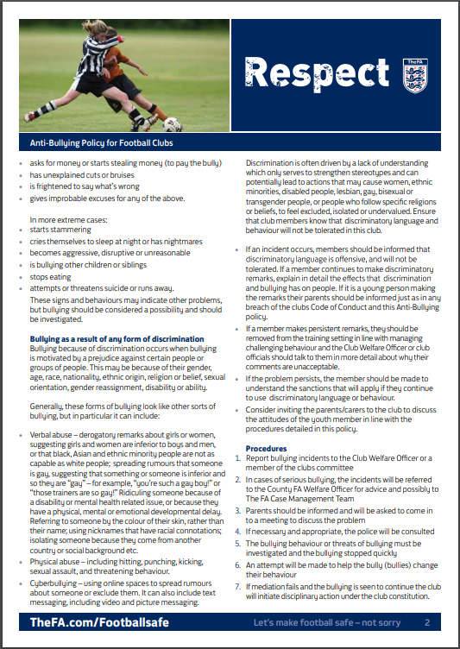

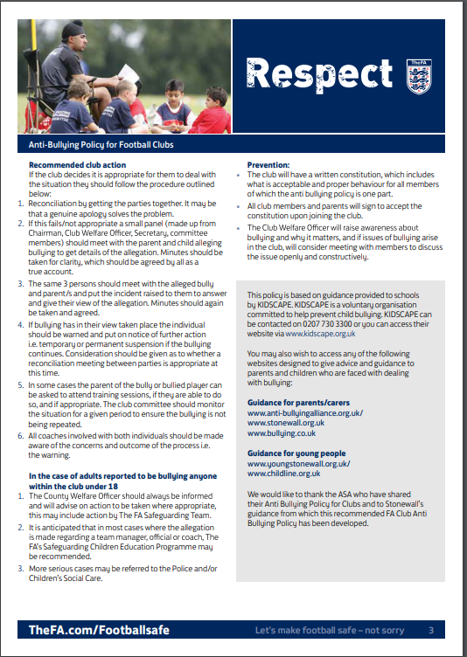

The FA Charter Standard
YORK FUTSAL SAFEGUARDING CHILDREN POLICY AND PROCEDURES

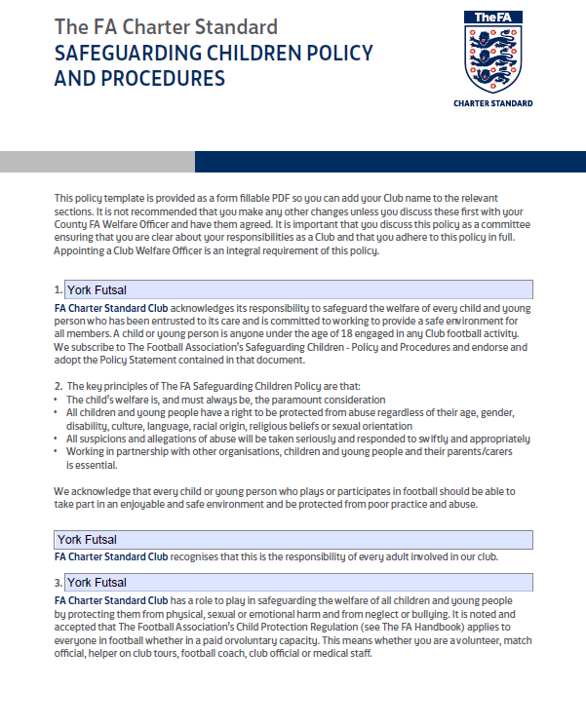

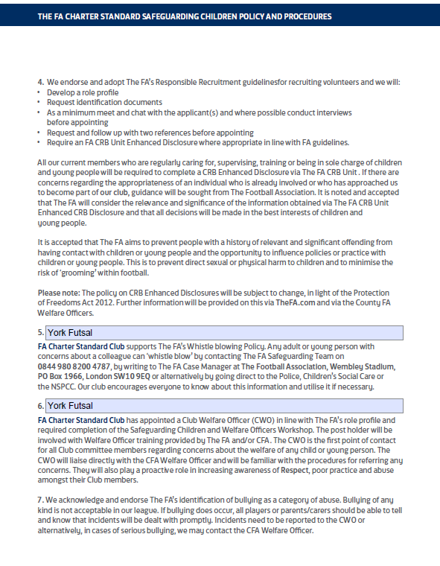

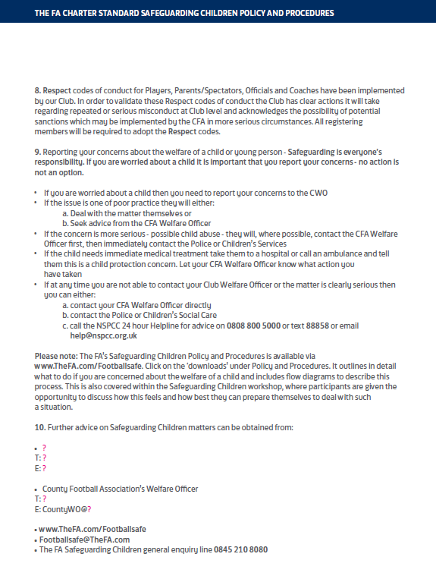

The FA Charter Standard
YORK FUTSAL EQUALITY POLICY

The FA Charter Standard
YORK FUTSAL SOCIAL MEDIA POLICY

The FA Charter Standard
YORK FUTSAL TRAVEL POLICY

The FA Charter Standard
YORK FUTSAL PHOTOGRAPHY POLICY

The FA Charter Standard
YORK FUTSAL PLAYER RECRUITMENT POLICY

The FA Charter Standard
YORK FUTSAL COACH RECRUITMENT POLICY

The FA Charter Standard
YORK FUTSAL VOLUNTEER RECRUITMENT POLICY

The FA Charter Standard
YORK FUTSAL DEALING WITH AN INCIDENT POLICY

The FA Charter Standard
YORK FUTSAL FORMS

